ANNEXURE I

**A PROJECT REPORT ON**

**“RakthDaan Android Application”**

*Submitted to*

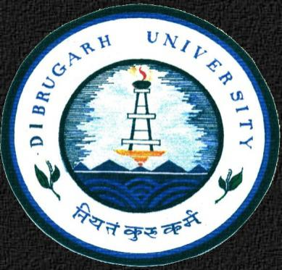

**DIBRUGARH UNIVERSITY**

**By**

* **MD. SAIFUL ISLAM TAPADAR (**17992043**)**
* **ARUNAV CHETIA (**17992017**)**

**In partial fulfillment for minor project of fifth semester**

**BACHELOR OF COMPUTER APPLICATIONS**

**CENTRE FOR COMPUTER SCIENCE AND APPLICATIONS**

**DIBRUGARH UNIVERSITY,**

**DIBRUGARH – 786004,**

**ASSAM, INDIA.**

**BATCH (2017-2020)**

ANNEXURE II

**CERTIFICATE**

This is to certify that the project report entitled **“ RakthDaan Android Application”** submitted by **MD.** **SAIFUL ISLAM TAPADAR (17992043)** and **ARUNAV CHETIA (17992017)** to DIBRUGARH UNIVERSITY, DIBRUGARH, ASSAM, in partial fulfillment for minor project of fifth semester **Bachelor of Computer Applications**. It is a bonafide record of the project work carried out by them under my supervision during the session Aug.2019-Dec.2019.

Guide:

(Name and signature of the guide with date)

ANNEXURE III

**CERTIFICATE**

This is to certify that the project report entitled **“RakthDaan Android Application”** submitted by **MD.** **SAIFUL ISLAM TAPADAR (17992043)** and **ARUNAV CHETIA (17992017)** to DIBRUGARH UNIVERSITY, DIBRUGARH, ASSAM, in partial fulfillment for minor project of fifth semester **Bachelor of Computer Applications**. It is a bonafide record of the project work carried out by them during the session Aug.2019-Dec.2019.

Chairperson,

( Dr. Gopal Chandra Hazarika)

CCSA, DU

ANNEXURE IV

**EXAMINATION CERTIFICATE**

This is to certify that the project report entitled **“RakthDaan Android Application”** submitted by **MD. SAIFUL ISLAM TAPADAR (17992043)** and **ARUNAV CHETIA (17992017)** of Centre for Computer Science and Applications, Dibrugarh University has carried out the Project Work in a manner satisfactory to warrant its acceptance and also defended it successfully. I wish him them all the success in their future endeavour.

**Examiners:**

1. **External Examiner:**

**02. Internal Examiner:**

ANNEXURE V

**DECLARATION**

We hereby declare that the Dissertation work entitled **“RakthDaan Android Application”** submitted to the Dibrugarh University, Dibrugarh, Assam, in partial fulfillment for minor project of fifth semester **Bachelor of Computer Applications.** It is an original work done by us under the guidance of **Dr. PRIYAKSHI MAHANTA** and has not been submitted for the award of any degree.

**Signature of the student’s**

Name : MD. SAIFUL ISLAM TAPADAR

Roll No. : 17992043

CCSA, DU

Name : ARUNAV CHETIA

Roll No. : 17992017

CCSA, DU

ANNEXURE VI

**ACKNOWLEDGEMENT­**

The present project work is a humble and maiden effort of the work concerned with the **“RakthDaan Android Application”** and has been a large success for the generous help and guidance received by us from several persons and quarters.

We also extend deep gratitude to my project guide for hes guidance and hes encouragement for us, it was unfailing source of reward experience.

We also express our gratitude to, for providing generous advice and moral support.

We are also t­­­thankfulness to all teachers for their help and timely advice

Finally thanks to all our friends in the department for their kind co-operation and help inside as well as outside the college.

MD. SAIFUL ISLAM TAPADAR

ARUNAV CHETIA

BCA 5TH SEMESTER

CCSA, DIBRUGARH UNIVERSITY

**ABSTRACT**

“**RakthDaan Android Application**” is an Android application for finding available blood donors around the locality without wandering here and there.

We are focusing on building a network of people who can help each other during an emergency. We have provided security for authenticated users as new users have to register according to their requirements and perspectives and existing users have to login. This application regularly updates the information about the donors and the administrator has complete access to the information about blood donation application.

We designed this application for android users to use it conveniently and off-course it's easy to operate.

For the donors we assured you the donors will be fully certified.

**CONTENTS**

1. **SYSTEM REQUIREMENT ……………….1-3**
2. **INTRODUCTION ………………………….4-5**
3. **SYSTEM DESIGN …………………………6-9**
4. **SOURCE CODE SNIPPETS…………………...10-11**
5. **SNAPSHOTS ………………………………..12-13**
6. **FUTURE DIRECTION……………………………14**
7. **CONCLUSION …………………..15**
8. **REFERENCES…………………………16**

**FIGURE INDEX**

**DATA FLOW DIAGRAM ……………………**

**DFD: LEVEL 0………….6**

**DFD: LEVEL 1………….7**

**UML DIAGRAM ……………………………..8**

**DATABASE DIAGRAM …………………….9**

**1. SYSTEM REQUIREMENTS:**

**1.1 Software used :**

* Development Tool : Android Studio (IDE + Code editor )
* Backend: Firebase
* Database: NoSQL

**1.2 Language used :**

* Java
* XML
* **Java**

Java is a general-purpose computer ****programming language**** that is [concurrent](https://howtodoinjava.com/java-concurrency-tutorial/), class-based, [object-oriented](https://howtodoinjava.com/oops/object-oriented-principles/), and specifically designed to have as few implementation dependencies as possible. It is intended to let application developers ****“write once, run anywhere” (WORA)****, meaning that compiled Java code can run on all platforms that support Java without the need for recompilation.

For example, you can write and compile a Java program on UNIX and run it on Microsoft Windows, Macintosh, or UNIX machine without any modifications to the source code. WORA is achieved by compiling a Java program into an intermediate language called ****bytecode****. The format of bytecode is platform-independent. A virtual machine, called the [Java Virtual Machine (JVM)](https://howtodoinjava.com/java/basics/jdk-jre-jvm/), is used to run the bytecode on each platform.

* **Firebase**

Google Firebase is a Google-backed application development software that enables developers to develop iOS, Android and [Web apps](https://searchsoftwarequality.techtarget.com/definition/Web-application-Web-app). Firebase provides tools for tracking analytics, reporting and fixing app crashes, creating marketing and product experiment.

Firebase offers a number of services, including:

* Analytics – Google Analytics for Firebase offers free, unlimited reporting on as many as 500 separate [events](https://searchmicroservices.techtarget.com/definition/event). Analytics presents data about user behavior in iOS and Android apps, enabling better decision-making about improving performance and app marketing.
* Authentication – Firebase Authentication makes it easy for developers to build secure authentication systems and enhances the sign-in and [onboarding](https://searchhrsoftware.techtarget.com/definition/employee-onboarding-and-offboarding/) experience for users. This feature offers a complete identity solution, supporting email and password accounts, phone auth, as well as Google, Facebook, [GitHub](https://searchitoperations.techtarget.com/definition/GitHub), Twitter login and more.
* Cloud messaging – Firebase Cloud Messaging ([FCM](https://whatis.techtarget.com/definition/Firebase-Cloud-Messaging-FCM)) is a cross-platform messaging tool that lets companies reliably receive and deliver messages on iOS, Android and the web at no cost.
* Realtime database – the Firebase Realtime Database is a cloud-hosted [NoSQL](https://searchdatamanagement.techtarget.com/definition/NoSQL-Not-Only-SQL') database that enables data to be stored and synced between users in real time. The data is synced across all clients in real time and is still available when an app goes offline.
* Crashlytics – Firebase Crashlytics is a real-time crash reporter that helps developers track, prioritize and fix stability issues that reduce the quality of their apps. With crashlytics, developers spend less time organizing and troubleshooting crashes and more time building features for their apps.
* Performance – Firebase Performance Monitoring service gives developers insight into the performance characteristics of their iOS and Android apps to help them determine where and when the performance of their apps can be improved.
* Test lab – Firebase Test Lab is a cloud-based app-testing infrastructure. With one operation, developers can test their iOS or Android apps across a variety of devices and device configurations. They can see the results, including videos, screenshots and logs, in the Firebase console.
* **NoSQL**

NoSQL is a non-relational DMS, that does not require a fixed schema, avoids joins, and is easy to scale. NoSQL database is used for distributed data stores with humongous data storage needs. NoSQL is used for Big data and real-time web apps. For example, companies like Twitter, Facebook, Google that collect terabytes of user data every single day.

NoSQL database stands for "Not Only SQL" or "Not SQL." Though a better term would NoREL NoSQL caught on. Carl Strozz introduced the NoSQL concept in 1998.

Traditional RDBMS uses SQL syntax to store and retrieve data for further insights. Instead, a NoSQL database system encompasses a wide range of database technologies that can store structured, semi-structured, unstructured and polymorphic data.

**1.3 Hardware Requirements:**

* + RAM 512MB
  + Space on Disk >10MB

**1.4 Software Requirements:**

* Android OS
* Android 4.4+

1. **INTRODUCTION**

Here what’s all about the project has been stated, from problem,scope to objective.

**2.1 PROBLEM DEFINITION**

It is estimated that our country has a blood deficit of between 30% and 35% every year. In a land of 1.2 billion people it's ridiculous to say we can't meet the requirement. "The problem is not insufficient number of donors, but finding a willing donor at the right time. We want to build a network of people who can help each other during an emergency.”. If someone needs blood, first of all he searches it within his family members, then nearest hospitals and blood banks. If they cannot manage blood in these ways, it is really hard for them to contact other people to collect blood in a short time. That is the problem we want to solve through our application. Instead of just providing people who need blood with an outdated list of regular donors who may or may not be available to help, Our application contacts the right people at the moment a user finds out about the need. Our Blood Donation Management System stores electronic information about the donors and organizations related to donating the blood.

**2.2 OBJECTIVE**

* What we aim for through this application, is that any person interested in donating blood can register himself as donor. Moreover if any general consumer wants to make request to have blood online, he can also take the help of this application. The main objective of this app is to improve the communication between donors and users and create for them a platform where they can interact each other easily, while overcoming the deficiencies of existing system.
* The objective is to save lives of peoples by providing blood to them whenever required

**2.3 SCOPE**

* In donor perspective he could help others and give a kind gesture to the society for a kind work.
* In receiver perspective he could easily find donor’s in urgency cases.
* Save time in wandering
* Portal for Blood Donors and Blood Receivers

1. **SYSTEM DESIGN**
   1. **DFD ( Data Flow Diagram )**

**3.1.1 LEVEL 0**

The below diagram is a 0-level DFD that only shows the flow of data between the various entity and the system. In this, it displays how the receivers and donors are interacting with the application.

**request from receivers**

**request add details**

**RECEIVER**

**RakthDaan**

**Donor**

**response response**

**Fig: - DFD Level-0**

**3.1.2 LEVEL 1**

The below shown diagram is a 1-level Data Flow Diagram of the application. According to this DFD various process are done after login process. After the registration process how both type of users can interact with the application.

**Edit Info**

**update**

**Database**

**user info**

**update**

**Create account**

**user info**

**Edit Info**

**Receiver**

**user info**

**donate**

**response**

**send**

**response**

**Donor**

**Requests**

**check availability**

**Fig: - DFD Level-1**

* 1. **Use Case Diagram (UML)**

The below use case diagram shows the relationship between Donor Receiver and Admin

`

Admin

Blood Donor

Blood Receiver

**Fig: - Use Case Diagram**

Checks for donor certification

Search donor and contact

Add Profile

Login

Registration

**DATABASE**

* **Donor**

|  |  |  |  |
| --- | --- | --- | --- |
| **S. No.** | **Field Name** | **Data Type** | **Description** |
|  | available | number | Availability of donor |
|  | birth | string | Date of Birth of Donor |
|  | blood | string | Blood Group of Donor |
|  | district | string | District of Donor |
|  | name | string | Name of Donor |
|  | phone | string | Phone Number of Donor |
|  | selectGender | string | Gender of Donor |
|  | state | string | State of Donor |
|  | verified | number | Whether user is verified donor |

* **Receiver**

|  |  |  |  |
| --- | --- | --- | --- |
| **S. No.** | **Field Name** | **Data Type** | **Description** |
| 1. | name | string | Name of Receiver |
| 2. | phoneno | string | Phone Number of Receiver |
| 3. | selectGender | string | Gender of Receiver |

1. **SOURCE CODE SNIPPETS**

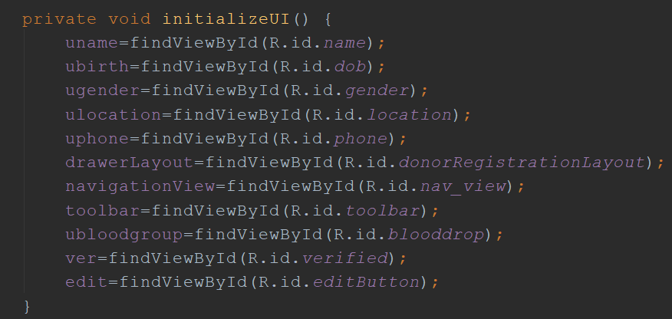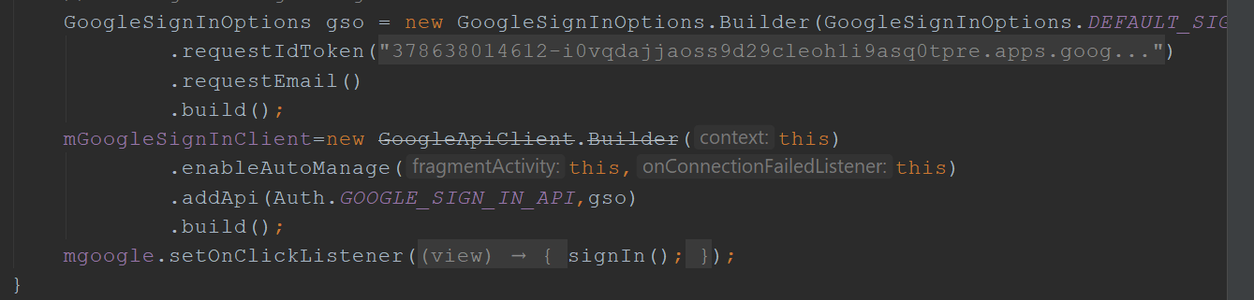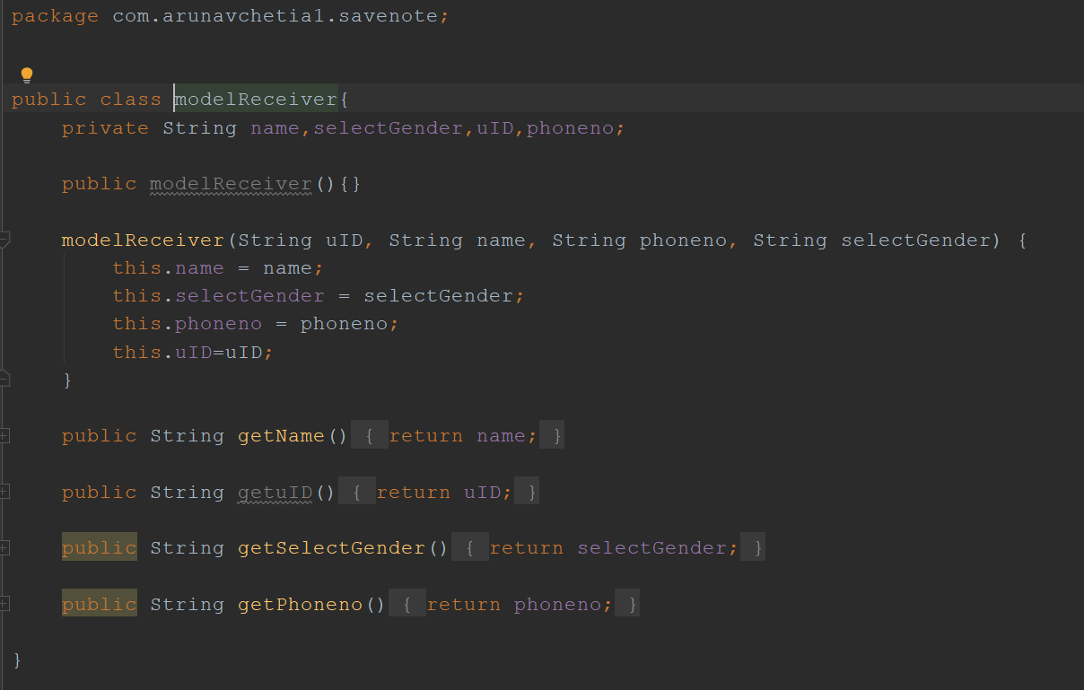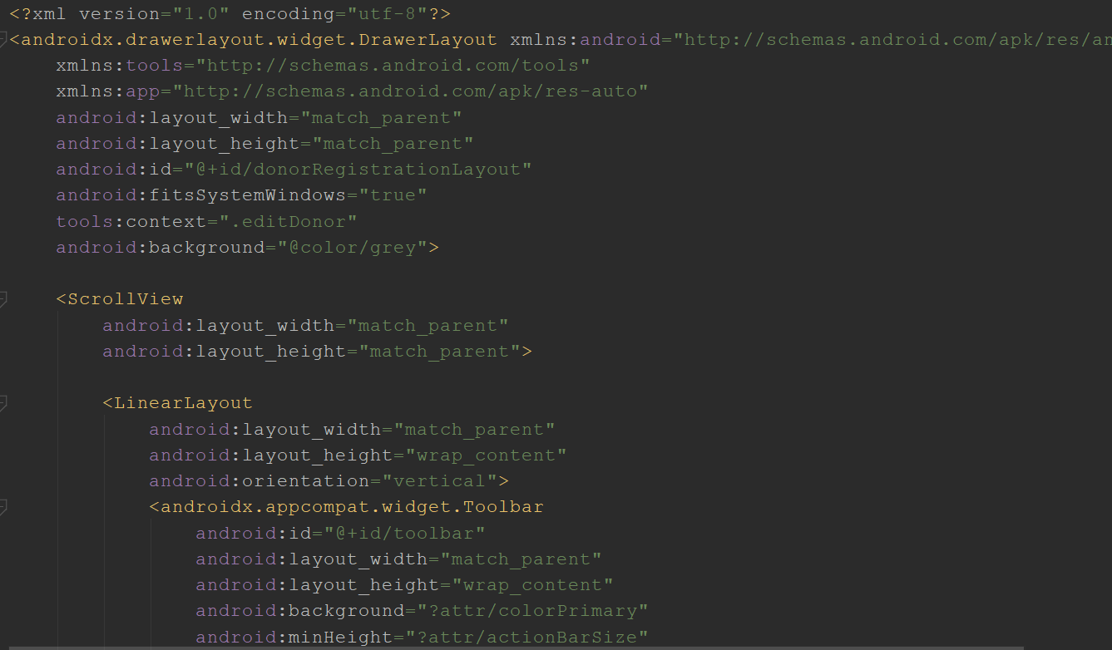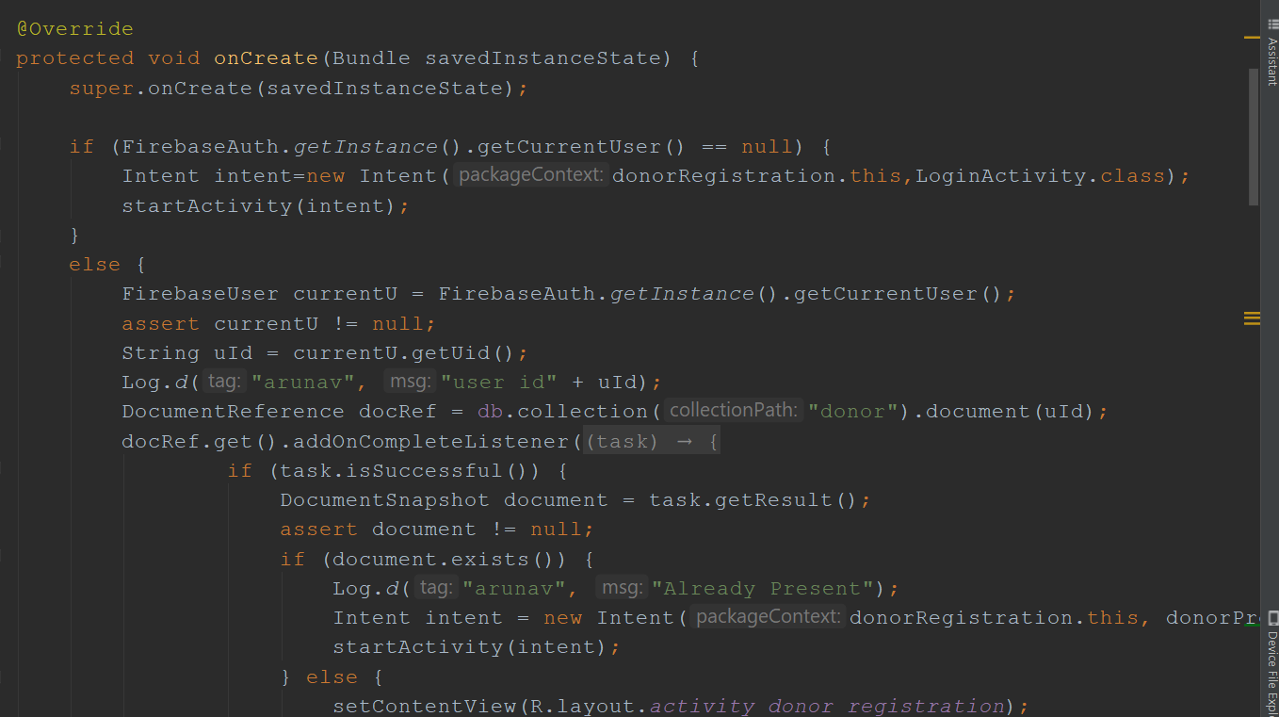

1. **SNAPSHOTS**
2. **FUTURE DIRECTIONS**
3. RakthDaan v2.0
4. More Interactive
5. One to One chat and voice functions
6. Location of donors real time
7. Real-time request for receiving or donating
8. Adding sections for Blood Banks and Hospitals
9. **CONCLUSION**

The android application for blood donation can be used by a lot of people and will help a lot of different communities like the doctors, donors, receivers and other general public. The user can be a blood donor as well as a recipient, this user can use the features of the application. The goal of the application is to provide solution to the existing deficit of blood and will connect the donors and the receivers who need blood. The application will get continuous updates from the hospital regarding the quantity of blood available. This application will solve the current problem that the world is facing, and hence save a lot of lives. This is the solution that we have for the existing problem

1. **REFERENCES**
2. <https://developer.android.com/studio/write/firebase>

“As recorded on - Sept.03.2019”

1. <https://developer.android.com/guide/topics/ui/declaring-layout>

“As recorded on - Oct.22.2019”

1. [file:///C:/Users/asus/Downloads/365351948-Android-Application-For-Blood-Donation.pdf](C:/Users/asus/Downloads/365351948-Android-Application-For-Blood-Donation.pdf)

“As recorded on - Nov.20.2019”

1. <https://icons8.com/>

“As recorded on - Nov.01.2019”

1. <https://developer.android.com/reference/java/util/HashMap>

“As recorded on - Sept.10.2019”

1. <https://www.flaticon.com/packs/avatar-set>

“As recorded on - Nov.01.2019”

1. <https://firebase.google.com/docs/firestore/query-data/get-data>

“As recorded on - Sept.06.2019”